实验十二 简单光照和材质

一、实验目的
1、进一步掌握3D编程概念：
2、了解和掌握三维场景中如何设置简单光照和材质效果
3、如何添加音乐程序
二、实验环境
硬件要求：
PC机，主流配置，最好为独立显卡，显存512M以上。
软件环境：
操作系统：Windows 7/Windows10。
语言开发工具：Microsoft Visual studio 2010/2017,Visual C/C++。
程序框架：Win32应用程序

三、实验内容与要求
- 要求： 按照实验内容步骤要求修改实验代码，当场检查效果，实验代码保存备用。

- 内容
1、3D 旋转世界的光照和材质设置
附属程序3D_scene_with_roaming.cpp为交互的3D场景，可用WSAD来实现直走和左右看，相当于场景的漫游效果。3D场景为一个圆环、一个小球和一个以四边形为基本单位的方块墙包围盒，且小球和圆环在“方块墙”的包围盒中。视点设在正前方观察物体，小球绕着环心某处不停旋转，并和圆环一起绕着环心不停旋转。改写程序，实现光照材质效果，圆环和小球用不同材质颜色，墙面、地面和天花实现不同颜色方块交替排列。并运行查看光照效果，如图12-1，并进一步了解OpenGL光照材质程序代码编写规则。
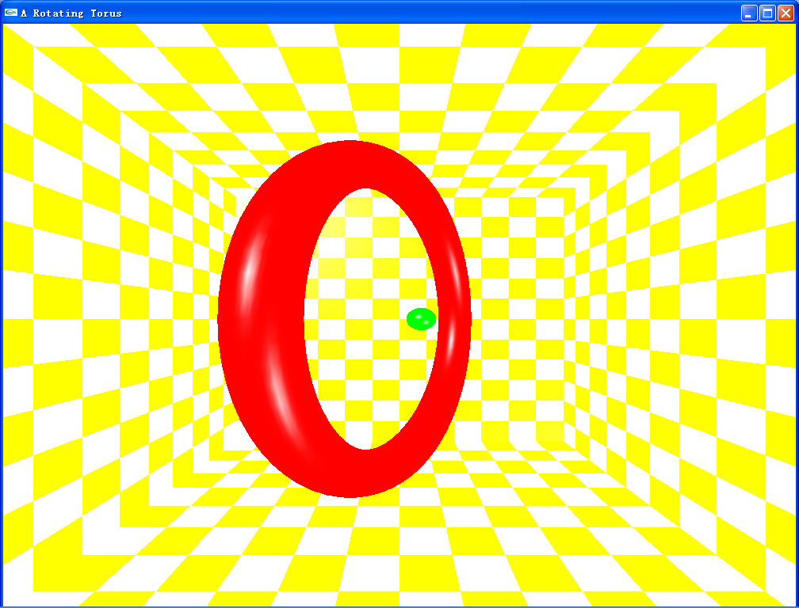
图12-1 带光照和材质效果的3D场景

OpenGL光照材质程序主要思路：
1） 将线框模型改为实体或面模型，多边形模式设为填充模式
glPolygonMode(GL_FRONT_AND_BACK,GL_FILL);
2） 启用深度检测效果
- 在主函数中指定一个32位深度缓冲区 glutInitDisplayMode(GLUT_RGB|GLUT_DOUBLE|GLUT_DEPTH);
- 在初始化设置函数中 启用深度检测：
glEnable(GL_DEPTH_TEST);
- 在绘制函数中清除上一次的深度缓存
glClear(GL_COLOR_BUFFER_BIT|GL_DEPTH_BUFFER_BIT);
3） 设置光源类型、光源数量、光源位置和方向、光源强度（一般在初始化程序中）
4） 启用光源（一般在初始化程序中）
5） 颜色设为光滑模式（一般在初始化程序中）
glShadeModel(GL_SMOOTH);
6） 设置物体材质各参数
7） 测试修改参数
8）光照材质设置代码示例见9.5节中的“5.光照材质设置代码示例”

回答下列问题：
1）程序用到几个光源？光源的性质？光源的位置相对于物体位置如何？
2）改变光源参数，如光源的位置、光的三个分量强度、光源的数量等参数，光照效果受到什么影响？
3）改变材质参数，材质分量、材质系数等，光照效果又会受到什么影响？
4）将3D小球物体替换为一个立方体，一个茶壶或其他3D物体查看效果不同？
5）记录和保存各种不同光照条件下的效果图及其相应的光照参数、材质参数参数，相互进行比较，光的距离、光的类型、光的强度、光的分量强度，以及材质的分量强度对场景效有什么影响？

2、给以上程序添加音乐效果
  - mp3 音乐的播放
1）准备
#include "fmod.h" //// 音频库的头文件
#pragma comment(lib, "fmodvc.lib") // 把音频库加入到链接器中
（将fmod.dll放至c:\windows\system32下，或者放至当前文件夹下）
2）变量定义 FSOUND_STREAM *mp3back;
3）// 载入音频文件，一般放在init()函数中
if (FSOUND_Init(44100, 32, 0)) // 把声音初始化为44khz
{
// 载入文件1.mp3
mp3back = FSOUND_Stream_OpenFile("1.mp3", FSOUND_LOOP_NORMAL, 0);
}
4）音乐播放 FSOUND_Stream_Play(FSOUND_FREE,mp3back);
5）停止播放 FSOUND_Stream_Stop(mp3back);
6）关闭音乐 FSOUND_Stream_Close(mp3back);

  - wav音乐播放
#include "windows.h"
PlaySound("data/Impack.wav",NULL,SND_ALIAS|SND_ASYNC|SND_NOSTOP);

四、函数参考
1、 光照设置函数
void glLight{if} (GLenum light, GLenum pname,TYPE paramvalue); void glLight{if}v(GLenum light, GLenum pname,TYPE paramvalue);
light: 光源名称，可以是GL_LIGHT0,GL_LIGHT1,…GL_LIGHTi ，OpenGL至少支持8种独立光源
pname: 光源属性，如颜色、位置和方向等
paramvalue：pname参数的值
Value name | meaning | Default value
GL_AMBIENT | 环境光分量强度 | (0.0,0.0,0.0,1.0)
GL_DIFFUSE | 漫反射光分量强度 | (1.0,1.0,1.0,1.0)
GL_SPECULAR | 镜面光分量的强度 | (1.0,1.0,1.0,1.0)
GL_POSITION | 光源的位置 | (0.0,0.0,1.0,0.0)
GL_SPOT_DIRECTION | 聚光方向 | (0.0,0.0,-1.0)
GL_SPOT_EXPONENT | 聚光指数 | 0.0
GL_SPOT_CUTOFF | 聚光的截止角 | 180.0
GL_CONSTANT_ATTENUATION | 常数衰减因子 | 1.0
GL_LINEAER_ATTENUATION | 线性衰减因子 | 0.0
GL_QUADRATIC_ATTENUATION | 二次衰减因子 | 0.0

2、材质定义函数
void glMaterial{if} (GLenum face,GLenum pname,TYPE param);
void glMaterial{if}v (GLenum face,GLenum pname,TYPE param);
指定光照计算中的物体材质属性
face ：GL_FRONT,GL_BACK,GL_FRONT_AND_BACK
例多边形有正反面，每个面都可能有相同或不同的属性
param: face的参数，指其漫反射、镜面反射和环境光反射的颜色特性，参数为4维，第4个分量设为1，假定物体为不透明物体。

pname | default | meaning
GL_AMBIENT | (0.2,0.2,0.2,1.0) | 材质的环境光颜色
GL_DIFFUSE | (0.8,0.8,0.8,1.0) | 材质的漫反射光颜色
GL_AMBIENT_DIFFUSE |  | 材质的环境光和漫反射光颜色
GL_SPECULAR | (0.0,0.0,0.0,1.0) | 材质的镜面反射光颜色
GL_SHINENESS | 0.0 | 镜面反射指数
GL_EMISSION | (0.0,0.0,0.0,1.0) | 材质的辐射光颜色
GL_COLOR_INDEXS | (0,1,1) | 材质的环境光、漫反射光和镜面反射光颜色的索引

3、材质颜色相符函数
glColorMaterial(GLenum face,GLenum mode);
允许材质的颜色跟踪glColor设置的颜色
face: 指定材质属性的表面，同前。
mode：指哪种材质属性要更新与glColor设置的颜色保持一致，取值:
GL_AMBIENT、GL_DIFFUSE、GL_AMBIENT_AND_DIFFUSE、GL_SPECULAR或GL_EMISSION
调用glColorMaterial()之前，还必须启用该功能,例如：
glEnable(GL_COLOR_MATERIAL);
glColorMaterial(GL_FRONT,GL_AMBIENT_AND_DIFFUSE);
glColor3f(0.2,0.5,0.8);
drawtriangle();
glDisable(GL_COLOR_MATERIAL);

4、中文字体绘制 参考实验七

5、快捷菜单
1）在主程序中创建菜单：
glutCreateMenu(mymenu); //创建菜单
glutAddMenuEntry("线框模型",1); //第一个菜单名“线框模型”，设置1为该菜单参数
glutAddMenuEntry("实体模型",2); //第二个菜单名“实体模型”，设置2为该菜单参数
glutAddMenuEntry("音乐播放",3); //第三个菜单名“音乐播放”，设置3为该菜单参数
glutAddMenuEntry("音乐停止",4); //第四个菜单名“音乐停止”，设置4为该菜单参数
glutAttachMenu(GLUT_RIGHT_BUTTON); //菜单附到鼠标右键

2） 声明菜单函数
void mymenu(int value); //在程序头部声明菜单子函数

3）定义菜单函数
void mymenu(int value)
{
//如果菜单参数为1，则执行线框模式
if(value==1) glPolygonMode(GL_FRONT_AND_BACK,GL_LINE);
//如果菜单参数为2，则执行实心模式
if(value==2) glPolygonMode(GL_FRONT_AND_BACK,GL_FILL);
//如果菜单参数为3，则播放音乐
if (value==3) FSOUND_Stream_Play(FSOUND_FREE,mp3back);
//如果菜单参数为2，则音乐停止
if (value==4) FSOUND_Stream_Stop(mp3back);
}

- 光照代码示例
程序段9-4 光照材质设置示例代码
//define light position1
GLfloat light_position1[]={-outer,outer,outer+4*inner+50,0.0};
// GLfloat light_position1[]={0,0,0,0.0};
GLfloat light_position2[]={+outer,-outer,outer+inner,0.0};

//GLfloat light color1 环境光、漫反射光、镜面反射光，R、G、B、A
GLfloat light_ambient1[]={1.0,1.0,1.0,1.0};
GLfloat light_diffuse1[]={1.0,1.0,1.0,1.0};
GLfloat light_specular1[]={1.0,1.0,1.0,1.0};

//GLfloat light color2
GLfloat light_ambient2[]={0.8,0.8,0.8,1.0};
GLfloat light_diffuse2[]={0.8,0.8,0.8,1.0};
GLfloat light_specular2[]={0.8,0.8,0.8,1.0};

// light model- global light
GLfloat lmodel_ambient[]={0.8,0.2,0.2,1.0};
glLightModelfv(GL_LIGHT_MODEL_AMBIENT, lmodel_ambient);
glLightModeli(GL_LIGHT_MODEL_LOCAL_VIEWER,GL_TRUE);

// set light source location
glLightfv(GL_LIGHT0,GL_POSITION,light_position1);
glLightfv(GL_LIGHT1,GL_POSITION,light_position2);

// set light source color; 灯1
glLightfv(GL_LIGHT0,GL_AMBIENT,light_ambient1);
glLightfv(GL_LIGHT0,GL_DIFFUSE,light_diffuse1);
glLightfv(GL_LIGHT0,GL_SPECULAR,light_specular1);

// set light source color; 灯2
glLightfv(GL_LIGHT1,GL_AMBIENT,light_ambient2);
glLightfv(GL_LIGHT1,GL_DIFFUSE,light_diffuse2);
glLightfv(GL_LIGHT1,GL_SPECULAR,light_specular2);

// set material let material fits color 材质
glEnable(GL_COLOR_MATERIAL);
glColorMaterial(GL_FRONT,GL_AMBIENT_AND_DIFFUSE);

//make light source enable;
glEnable(GL_LIGHTING); //启用光源
glEnable(GL_LIGHT0); //打开第一盏灯
glEnable(GL_LIGHT1); //打开第二盏灯

//Color shade mode
glShadeModel(GL_SMOOTH);
// glShadeModel(GL_FLAT);

//Material parameter setting
GLfloat mat_specular1[]={1.0,1.0,1.0,1.0};
GLfloat mat_shininess1[]={80.0};
glMaterialfv(GL_FRONT,GL_SPECULAR,mat_specular1);
glMaterialfv(GL_FRONT,GL_SHININESS,mat_shininess1);

六、思考题
1、如果用鼠标来进行左右上下拖拽整个场景，程序又如何修改？
2、在此基础上再实现镜头的放大缩小，俯视等，程序应该如何修改？
3、本程序中用到什么技巧使颜色规律变换？

七、演示程序
1、 3D_Rotating_World_with_lingt_&_Material.exe
2、 Material.exe
3、 light sphere.exe
4、 light control.exe

八、课后思考题
1、 小球的光照和材质设置
附录中Material.cpp程序为场景光照不变，小球的材质不同，小球的显示效果各不相同，运行查看光照效果结果。
修改程序，修改小球材质参数，观看效果。
改变小球材质的参数，光照效果受到什么影响？记录和保存原始效果图及其参数和各种参数修改后的效果截图和具体光照参数，看能否得出一些结论。

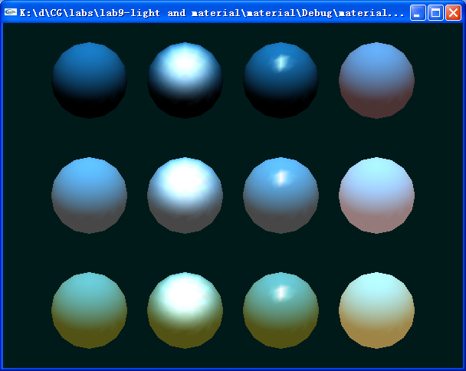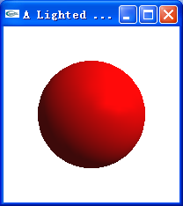
图12-2 材质小球 图12-3 光照材质小球
另一个程序light sphere.cpp只绘制了一个小球，包括有灯光和材质的设置，也可参考。

2、 光源位置控制程序
运行附录程序lightcontrol.cpp, 鼠标单击后，小球（即光源）位置会发生变化，从而光照效果发生变化。了解光照位置对光照效果的影响。
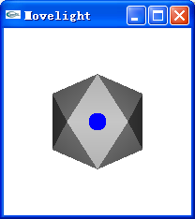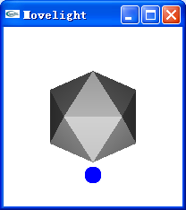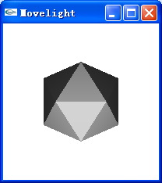
a)位置1 b) 位置2 c) 位置3
图12-4 光照位置控制程序效果

九、附属程序
1、 3D_scene_with_roaming.cpp
#include "stdafx.h"
#include <math.h>
#include <glut.h>
#define PI 3.14159
float theta=-90.0; //rotating angle
int inner=10,outer=80; //torus's inner & outer radius
float s=outer+4*inner+50;
float eyex=0,eyey=0,eyez=s; //eye point initial position
float atx=0,aty=0,atz=0; //at point initial position
int ww,hh; //variable for windows's width
bool flag=true;
float angle=0; //for angle between view-line and z axis
float r=s; //for distance between eye and at
float step=r/10; //for forward and backword step;

void Display(void);
void Reshape(int w, int h);
void mytime(int value);
void drawground();
void drawsphere();
void drawwall();
void init();
void mykeyboard(unsigned char key, int x, int y);

int APIENTRY _tWinMain(HINSTANCE hInstance,
HINSTANCE hPrevInstance,
LPTSTR lpCmdLine,
int nCmdShow)
{
UNREFERENCED_PARAMETER(hPrevInstance);
UNREFERENCED_PARAMETER(lpCmdLine);
char *argv[] = {"hello ", " "};
int argc = 2; // must/should match the number of strings in argv
glutInit(&argc, argv); //初始化GLUT库；
glutInitDisplayMode(GLUT_RGB|GLUT_DOUBLE|GLUT_DEPTH);
glutInitWindowSize(500, 500);
glutInitWindowPosition(1024 / 2 - 250, 768 / 2 - 250);
glutCreateWindow("Rotating 3D World"); //创建窗口，标题为“Rotating 3D World”；
glutReshapeFunc(Reshape);
init();
glutDisplayFunc(Display); //用于绘制当前窗口；
glutKeyboardFunc(mykeyboard);
glutTimerFunc(100,mytime,10);
glutMainLoop(); //表示开始运行程序，用于程序的结尾；
return 0;
}

void init()
{
glClearColor(1,1,1,1);
glEnable(GL_DEPTH_TEST);
glPixelStorei(GL_PACK_ALIGNMENT, 1);
glPolygonMode(GL_FRONT_AND_BACK,GL_LINE);
}

void mykeyboard(unsigned char key, int x, int y)
{
switch(key)
{ case 'W':
case 'w':// 向前直走
//your code Here
eyex=eyex-step*sin(angle*PI/180.0);
eyez=eyez-step*cos(angle*PI/180.0);
atx=atx-step*sin(angle*PI/180.0);
atz=atz-step*cos(angle*PI/180.0);
break;
case 'S':
case 's'://向后退
//your code Here
eyex=eyex+step*sin(angle*PI/180.0);
eyez=eyez+step*cos(angle*PI/180.0);
atx=atx+step*sin(angle*PI/180.0);
atz=atz+step*cos(angle*PI/180.0);
break;
case 'A':
case 'a'://左看
//your code Here
angle=angle+1;
atx=eyex-r*sin(angle*PI/180.0);
atz=eyez-r*cos(angle*PI/180.0);
break;
case 'D':
case 'd'://右看
//your code Here
angle=angle-1;
atx=eyex-r*sin(angle*PI/180.0);
atz=eyez-r*cos(angle*PI/180.0);
break;
}
glutPostRedisplay();//参数修改后调用重画函数，屏幕图形将发生改变
}

void Display(void)
{
glClear(GL_COLOR_BUFFER_BIT|GL_DEPTH_BUFFER_BIT);
glMatrixMode(GL_MODELVIEW);
glLoadIdentity();
gluLookAt(eyex,eyey,eyez,atx,aty,atz,0,1,0);
glPushMatrix();
glColor3f(0.0,0.0,1.0);
drawwall();
glColor3f(1.0,0,0);
drawground();
drawsphere();
glPopMatrix();
glutSwapBuffers();
}

void drawsphere()
{
float tr;
tr=(outer+3*inner);
glRotatef(theta,0,1,0);
glPushMatrix();
glPushMatrix();
glColor3f(1.0,0,1.0);
glutWireTorus(inner,outer,30,50);
glPopMatrix();

glPushMatrix();
glTranslatef(outer,0,0);
glRotatef(theta,0,1,0);
glTranslatef(-outer,0,0);

glPushMatrix();
glTranslatef(tr,0,0);
glRotatef(-45,1,0,0);
glColor3f(0.0,1.0,0);
glutWireSphere(inner,20,20);
glPopMatrix();
glPopMatrix();
glPopMatrix();
}

void drawground()
{
//ground
for (int i=-outer-4*inner;i<outer+4*inner;i+=2*inner)
for (int j=-outer-4*inner;j<outer+4*inner;j+=2*inner)
{
glBegin(GL_QUADS);
glVertex3d(j,-outer-4*inner,i);
glVertex3d(j,-outer-4*inner,i+2*inner);
glVertex3d(j+2*inner,-outer-4*inner,i+2*inner);
glVertex3d(j+2*inner,-outer-4*inner,i);
glEnd();
}

//top
for ( int i=-outer-4*inner;i<outer+4*inner;i+=2*inner)
for (int j=-outer-4*inner;j<outer+4*inner;j+=2*inner)
{
glBegin(GL_QUADS);
glVertex3d(j,outer+4*inner,i);
glVertex3d(j,outer+4*inner,i+2*inner);
glVertex3d(j+2*inner,outer+4*inner,i+2*inner);
glVertex3d(j+2*inner,outer+4*inner,i);
glEnd();
}
}

void drawwall()
{ int i,j;

glPolygonMode(GL_FRONT_AND_BACK,GL_LINE);

//left
for (i=-outer-4*inner;i<outer+4*inner;i+=2*inner)
for (j=-outer-4*inner;j<outer+4*inner;j+=2*inner)
{
glBegin(GL_QUADS);
glVertex3d(-outer-4*inner,j,i);
glVertex3d(-outer-4*inner,j+2*inner,i);
glVertex3d(-outer-4*inner,j+2*inner,i+2*inner);
glVertex3d(-outer-4*inner,j,i+2*inner);
glEnd();
}

//right
for (i=-outer-4*inner;i<=outer+4*inner-2*inner;i+=2*inner) //for z
for (j=-outer-4*inner;j<=outer+4*inner-2*inner;j+=2*inner) //for y
{
glBegin(GL_QUADS);
glVertex3f(outer+4*inner,j,i);
glVertex3f(outer+4*inner,j+2*inner,i);
glVertex3f(outer+4*inner,j+2*inner,i+2*inner);
glVertex3f(outer+4*inner,j,i+2*inner);
glEnd();
}

glColor3f(1.0,1.0,0.0);
//front
for (i=-outer-4*inner;i<=outer+4*inner-2*inner;i+=2*inner) //for z
for (j=-outer-4*inner;j<=outer+4*inner-2*inner;j+=2*inner) //for y
{
glBegin(GL_QUADS);
glVertex3f(j,i,-outer-4*inner);
glVertex3f(j+2*inner,i,-outer-4*inner);
glVertex3f(j+2*inner,i+2*inner,-outer-4*inner);
glVertex3f(j,i+2*inner,-outer-4*inner);
glEnd();
}
}

void mytime(int value)
{
theta+=0.5;
if (theta>=360.0) theta-=360.0;
glutPostRedisplay();
glutTimerFunc(100,mytime,10);
}

void Reshape(GLsizei w,GLsizei h)
{
glMatrixMode(GL_PROJECTION);
glLoadIdentity();
gluPerspective(90,w/h,10,2*outer+8*inner+250);
glViewport(0,0,w,h);
glMatrixMode(GL_MODELVIEW);
ww=w;
hh=h;
}

2、材质小球程序Material.cpp
#include <stdlib.h>
#include <GL/glut.h>

/* Initialize z-buffer, projection matrix, light source,
* and lighting model. Do not specify a material property here.
*/
void init(void)
{
GLfloat ambient[] = { 0.0, 0.0, 0.0, 1.0 };
GLfloat diffuse[] = { 1.0, 1.0, 1.0, 1.0 };
GLfloat specular[] = { 1.0, 1.0, 1.0, 1.0 };
GLfloat position[] = { 0.0, 3.0, 2.0, 0.0 };
GLfloat lmodel_ambient[] = { 0.4, 0.4, 0.4, 1.0 };
GLfloat local_view[] = { 0.0 };

glClearColor(0.0, 0.1, 0.1, 0.0);
glEnable(GL_DEPTH_TEST);
glShadeModel(GL_SMOOTH);

glLightfv(GL_LIGHT0, GL_AMBIENT, ambient);
glLightfv(GL_LIGHT0, GL_DIFFUSE, diffuse);
glLightfv(GL_LIGHT0, GL_POSITION, position);
glLightModelfv(GL_LIGHT_MODEL_AMBIENT, lmodel_ambient);
glLightModelfv(GL_LIGHT_MODEL_LOCAL_VIEWER, local_view);

glEnable(GL_LIGHTING);
glEnable(GL_LIGHT0);
}

// Draw twelve spheres in 3 rows with 4 columns.
void display(void)
{
GLfloat no_mat[] = { 0.0, 0.0, 0.0, 1.0 };
GLfloat mat_ambient[] = { 0.7, 0.7, 0.7, 1.0 };
GLfloat mat_ambient_color[] = { 0.8, 0.8, 0.2, 1.0 };
GLfloat mat_diffuse[] = { 0.1, 0.5, 0.8, 1.0 };
GLfloat mat_specular[] = { 1.0, 1.0, 1.0, 1.0 };
GLfloat no_shininess[] = { 0.0 };
GLfloat low_shininess[] = { 5.0 };
GLfloat high_shininess[] = { 100.0 };
GLfloat mat_emission[] = {0.3, 0.2, 0.2, 0.0};

glClear(GL_COLOR_BUFFER_BIT | GL_DEPTH_BUFFER_BIT);

/* draw sphere in first row, first column
* diffuse reflection only; no ambient or specular
*/
glPushMatrix();
glTranslatef (-3.75, 3.0, 0.0);
glMaterialfv(GL_FRONT, GL_AMBIENT, no_mat);
glMaterialfv(GL_FRONT, GL_DIFFUSE, mat_diffuse);
glMaterialfv(GL_FRONT, GL_SPECULAR, no_mat);
glMaterialfv(GL_FRONT, GL_SHININESS, no_shininess);
glMaterialfv(GL_FRONT, GL_EMISSION, no_mat);
glutSolidSphere(1.0, 16, 16);
glPopMatrix();

/* draw sphere in first row, second column
* diffuse and specular reflection; low shininess; no ambient
*/
glPushMatrix();
glTranslatef (-1.25, 3.0, 0.0);
glMaterialfv(GL_FRONT, GL_AMBIENT, no_mat);
glMaterialfv(GL_FRONT, GL_DIFFUSE, mat_diffuse);
glMaterialfv(GL_FRONT, GL_SPECULAR, mat_specular);
glMaterialfv(GL_FRONT, GL_SHININESS, low_shininess);
glMaterialfv(GL_FRONT, GL_EMISSION, no_mat);
glutSolidSphere(1.0, 16, 16);
glPopMatrix();

/* draw sphere in first row, third column
* diffuse and specular reflection; high shininess; no ambient
*/
glPushMatrix();
glTranslatef (1.25, 3.0, 0.0);
glMaterialfv(GL_FRONT, GL_AMBIENT, no_mat);
glMaterialfv(GL_FRONT, GL_DIFFUSE, mat_diffuse);
glMaterialfv(GL_FRONT, GL_SPECULAR, mat_specular);
glMaterialfv(GL_FRONT, GL_SHININESS, high_shininess);
glMaterialfv(GL_FRONT, GL_EMISSION, no_mat);
glutSolidSphere(1.0, 16, 16);
glPopMatrix();

/* draw sphere in first row, fourth column
* diffuse reflection; emission; no ambient or specular reflection
*/
glPushMatrix();
glTranslatef (3.75, 3.0, 0.0);
glMaterialfv(GL_FRONT, GL_AMBIENT, no_mat);
glMaterialfv(GL_FRONT, GL_DIFFUSE, mat_diffuse);
glMaterialfv(GL_FRONT, GL_SPECULAR, no_mat);
glMaterialfv(GL_FRONT, GL_SHININESS, no_shininess);
glMaterialfv(GL_FRONT, GL_EMISSION, mat_emission);
glutSolidSphere(1.0, 16, 16);
glPopMatrix();

/* draw sphere in second row, first column
* ambient and diffuse reflection; no specular
*/
glPushMatrix();
glTranslatef (-3.75, 0.0, 0.0);
glMaterialfv(GL_FRONT, GL_AMBIENT, mat_ambient);
glMaterialfv(GL_FRONT, GL_DIFFUSE, mat_diffuse);
glMaterialfv(GL_FRONT, GL_SPECULAR, no_mat);
glMaterialfv(GL_FRONT, GL_SHININESS, no_shininess);
glMaterialfv(GL_FRONT, GL_EMISSION, no_mat);
glutSolidSphere(1.0, 16, 16);
glPopMatrix();

/* draw sphere in second row, second column
* ambient, diffuse and specular reflection; low shininess
*/
glPushMatrix();
glTranslatef (-1.25, 0.0, 0.0);
glMaterialfv(GL_FRONT, GL_AMBIENT, mat_ambient);
glMaterialfv(GL_FRONT, GL_DIFFUSE, mat_diffuse);
glMaterialfv(GL_FRONT, GL_SPECULAR, mat_specular);
glMaterialfv(GL_FRONT, GL_SHININESS, low_shininess);
glMaterialfv(GL_FRONT, GL_EMISSION, no_mat);
glutSolidSphere(1.0, 16, 16);
glPopMatrix();

/* draw sphere in second row, third column
* ambient, diffuse and specular reflection; high shininess
*/
glPushMatrix();
glTranslatef (1.25, 0.0, 0.0);
glMaterialfv(GL_FRONT, GL_AMBIENT, mat_ambient);
glMaterialfv(GL_FRONT, GL_DIFFUSE, mat_diffuse);
glMaterialfv(GL_FRONT, GL_SPECULAR, mat_specular);
glMaterialfv(GL_FRONT, GL_SHININESS, high_shininess);
glMaterialfv(GL_FRONT, GL_EMISSION, no_mat);
glutSolidSphere(1.0, 16, 16);
glPopMatrix();

/* draw sphere in second row, fourth column
* ambient and diffuse reflection; emission; no specular
*/
glPushMatrix();
glTranslatef (3.75, 0.0, 0.0);
glMaterialfv(GL_FRONT, GL_AMBIENT, mat_ambient);
glMaterialfv(GL_FRONT, GL_DIFFUSE, mat_diffuse);
glMaterialfv(GL_FRONT, GL_SPECULAR, no_mat);
glMaterialfv(GL_FRONT, GL_SHININESS, no_shininess);
glMaterialfv(GL_FRONT, GL_EMISSION, mat_emission);
glutSolidSphere(1.0, 16, 16);
glPopMatrix();

/* draw sphere in third row, first column
* colored ambient and diffuse reflection; no specular
*/
glPushMatrix();
glTranslatef (-3.75, -3.0, 0.0);
glMaterialfv(GL_FRONT, GL_AMBIENT, mat_ambient_color);
glMaterialfv(GL_FRONT, GL_DIFFUSE, mat_diffuse);
glMaterialfv(GL_FRONT, GL_SPECULAR, no_mat);
glMaterialfv(GL_FRONT, GL_SHININESS, no_shininess);
glMaterialfv(GL_FRONT, GL_EMISSION, no_mat);
glutSolidSphere(1.0, 16, 16);
glPopMatrix();

/* draw sphere in third row, second column
* colored ambient, diffuse and specular reflection; low shininess
*/
glPushMatrix();
glTranslatef (-1.25, -3.0, 0.0);
glMaterialfv(GL_FRONT, GL_AMBIENT, mat_ambient_color);
glMaterialfv(GL_FRONT, GL_DIFFUSE, mat_diffuse);
glMaterialfv(GL_FRONT, GL_SPECULAR, mat_specular);
glMaterialfv(GL_FRONT, GL_SHININESS, low_shininess);
glMaterialfv(GL_FRONT, GL_EMISSION, no_mat);
glutSolidSphere(1.0, 16, 16);
glPopMatrix();

/* draw sphere in third row, third column
* colored ambient, diffuse and specular reflection; high shininess
*/
glPushMatrix();
glTranslatef (1.25, -3.0, 0.0);
glMaterialfv(GL_FRONT, GL_AMBIENT, mat_ambient_color);
glMaterialfv(GL_FRONT, GL_DIFFUSE, mat_diffuse);
glMaterialfv(GL_FRONT, GL_SPECULAR, mat_specular);
glMaterialfv(GL_FRONT, GL_SHININESS, high_shininess);
glMaterialfv(GL_FRONT, GL_EMISSION, no_mat);
glutSolidSphere(1.0, 16, 16);
glPopMatrix();

/* draw sphere in third row, fourth column
* colored ambient and diffuse reflection; emission; no specular
*/
glPushMatrix();
glTranslatef (3.75, -3.0, 0.0);
glMaterialfv(GL_FRONT, GL_AMBIENT, mat_ambient_color);
glMaterialfv(GL_FRONT, GL_DIFFUSE, mat_diffuse);
glMaterialfv(GL_FRONT, GL_SPECULAR, no_mat);
glMaterialfv(GL_FRONT, GL_SHININESS, no_shininess);
glMaterialfv(GL_FRONT, GL_EMISSION, mat_emission);
glutSolidSphere(1.0, 16, 16);
glPopMatrix();
glFlush();
}

void reshape(int w, int h)
{
glViewport(0, 0, w, h);
glMatrixMode(GL_PROJECTION);
glLoadIdentity();
if (w <= (h * 2))
glOrtho (-6.0, 6.0, -3.0*((GLfloat)h*2)/(GLfloat)w,
3.0*((GLfloat)h*2)/(GLfloat)w, -10.0, 10.0);
else
glOrtho (-6.0*(GLfloat)w/((GLfloat)h*2),
6.0*(GLfloat)w/((GLfloat)h*2), -3.0, 3.0, -10.0, 10.0);
glMatrixMode(GL_MODELVIEW);
glLoadIdentity();
}

void keyboard(unsigned char key, int x, int y)
{
switch (key) {
case 27:
exit(0);
break;
}
}

int main(int argc, char** argv)
{
glutInit(&argc, argv);
glutInitDisplayMode (GLUT_SINGLE | GLUT_RGB | GLUT_DEPTH);
glutInitWindowSize (600, 450);
glutCreateWindow(argv[0]);
init();
glutReshapeFunc(reshape);
glutDisplayFunc(display);
glutKeyboardFunc (keyboard);
glutMainLoop();
return 0;
}
3、小球光照材质程序light sphere.cpp
#include <GL/glut.h>
#include "windows.h"
void Display(void);
void Reshape(int w, int h);
void init();

int main(int argc, char** argv)
{
glutInit(&argc, argv);
glutInitWindowPosition(0,0);
glutInitWindowSize(200,200);
glutInitDisplayMode(GLUT_DOUBLE | GLUT_RGB|GLUT_DEPTH);
glutCreateWindow("A Lighted sphere");
init();
glutDisplayFunc(Display);
glutReshapeFunc(Reshape);
glutMainLoop();
return 0;
}

void Display(void)
{
glClearColor(1,1,1,1);
glClear(GL_COLOR_BUFFER_BIT|GL_DEPTH_BUFFER_BIT);
glMatrixMode(GL_MODELVIEW);
glLoadIdentity();
glTranslatef(0.0,0.0,-3.0);
glRotatef(60.0,1.0,0.0,0.0);
glutSolidSphere(1.0,30,60);
glutSwapBuffers();
}

void Reshape(GLsizei w,GLsizei h)
{
if (h==0) h=1;
glMatrixMode(GL_PROJECTION);
glLoadIdentity();
gluPerspective(60,w/h,1,20);
glViewport(0,0,w,h);
glMatrixMode(GL_MODELVIEW);
glLoadIdentity();
}

void init()
{
//define light position
GLfloat light_position[]={1.0,1.0,1.0,0.0};
//GLfloat light color
GLfloat light_ambient[]={1.0,0.0,0.0,1.0};
GLfloat light_diffuse[]={1.0,0.0,0.0,1.0};
GLfloat light_specular[]={1.0,0.0,0.0,1.0};

//define light source direction;
GLfloat light_direction[]={0.0,0.0,-1.0};

// set light source location
glLightfv(GL_LIGHT0,GL_POSITION,light_position);

// set light source color;
glLightfv(GL_LIGHT0,GL_AMBIENT,light_ambient);
glLightfv(GL_LIGHT0,GL_DIFFUSE,light_diffuse);
glLightfv(GL_LIGHT0,GL_SPECULAR,light_specular);

//set spotlight parameter
glLightfv(GL_LIGHT0,GL_SPOT_DIRECTION,light_direction);
glLightf(GL_LIGHT0,GL_SPOT_EXPONENT,0.0);
glLightf(GL_LIGHT0,GL_SPOT_CUTOFF,180);

//set light source attenuation
glLightf(GL_LIGHT0,GL_CONSTANT_ATTENUATION,1.0);
glLightf(GL_LIGHT0,GL_LINEAR_ATTENUATION,0.0);
glLightf(GL_LIGHT0,GL_QUADRATIC_ATTENUATION,1.0);

//define material property
GLfloat mat_specular[]={1.0,1.0,1.0,1.0};
GLfloat mat_shininess[]={50.0};
glMaterialfv(GL_FRONT,GL_SPECULAR,mat_specular);
glMaterialfv(GL_FRONT,GL_SHININESS,mat_shininess);

glClearColor(1.0,1.0,1.0,1.0);
glShadeModel(GL_SMOOTH);

//make light source enable;
glEnable(GL_LIGHTING);
glEnable(GL_LIGHT0);

glEnable(GL_DEPTH_TEST);

}

4、 光线位置控制程序lightcontrol.cpp
#include <windows.h>
#include <GL/glut.h>

int step=0;
void myinit(void)
{
glClearColor(1.0,1.0,1.0,1.0);
glShadeModel(GL_SMOOTH);
glEnable(GL_LIGHTING);
glEnable(GL_LIGHT0);
glEnable(GL_DEPTH_TEST);

}

void display(void)
{

// setting light source;
GLfloat position[]={0.0,0.0,4.0,1.0};
glClear(GL_COLOR_BUFFER_BIT|GL_DEPTH_BUFFER_BIT);

glMatrixMode(GL_MODELVIEW);
glLoadIdentity();
glPushMatrix();
glTranslatef(0,0,-10);
glPushMatrix();

//rotating light source;
glRotatef(step,1.0,0.0,0.0);
glLightfv(GL_LIGHT0,GL_POSITION,position);

glPushMatrix();
// blue sphere as a light source;
glTranslatef(0,0,4);
glDisable(GL_LIGHTING);
glColor3f(0,0,1);
glutSolidSphere(0.1,20,16);

glPopMatrix();

glPopMatrix();
glEnable(GL_LIGHTING);

//draw a 20th polyhons shined by light source;
glutSolidIcosahedron();

glPopMatrix();
glFlush();

}

// press mouse left button to rotate light source;
void mouse(int button, int state,int x,int y)
{
switch(button){
case GLUT_LEFT_BUTTON:
step+=5;
display();
break;
default:
break;
}
}

void myreshape(int w,int h)
{
glViewport(0,0,w,h);
glMatrixMode(GL_PROJECTION);
glLoadIdentity();
gluPerspective(20.0,(GLfloat)w/(GLfloat)h,1,20);
glMatrixMode(GL_MODELVIEW);
glLoadIdentity();
}

int main(int argc,char **argv)
{
glutInit(&argc,argv);
glutInitDisplayMode(GLUT_SINGLE|GLUT_RGB);
glutInitWindowSize(200,200); //屏幕分辨率1024*768
glutInitWindowPosition(150,150); //左上角为原点
glutCreateWindow("Movelight");
myinit();
glutDisplayFunc(display);
glutReshapeFunc(myreshape);
glutMouseFunc(mouse);

glutMainLoop();
return 0;
}

